Computer Vision Homework 4

Oron Barazani 305295818 & Roee Hadar 206390098

Part 1:

1.1 Eight-points algorithm

We constructed the fundamental matrix F using the Eight-points algorithm. The algorithm gets a set of matching points of size (N,2) in 2 cameras worlds and find the F matrix

* Normalizing points
* Construct A matrix of shape (9,N) using points to find appropriate transformation (find parameters of the transformation)
* Solving the following problem:
* We used SVD to find the solution to this problem
* Since F matrix estimation is noisy, we enforced the rank 2 constraint and also use the supplied helper function to refine F
* The results:

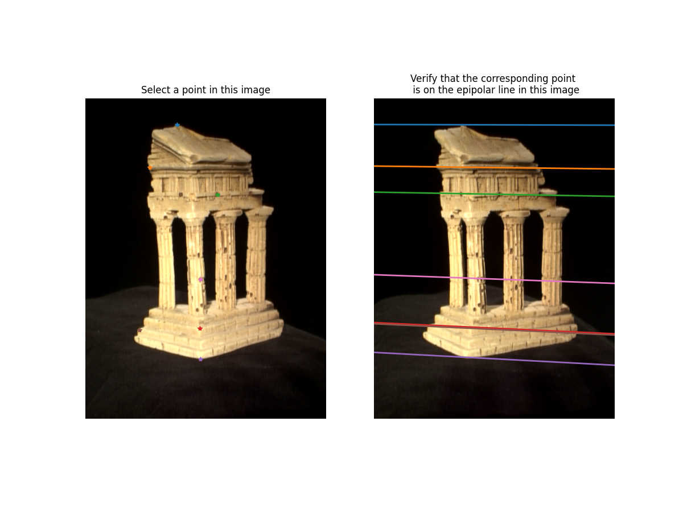And used the supplied GUI to view variety of epipolar lines in the second image corresponding to matching points in the first image:

1.2 Epipolar correspondence

We used F matrix that we have found in 1.1 and the supplied images to find the epipolar correspondence of each point in first image:

* For each point in the first image
* We find the epipolar line in the second image
* Along the epipolar line we look for the best matched point for
* The score determined by Euclidian distance between the 2 windows around each point – each window is in size
* The windows were normalized to improve results – more robust to illuminance difference

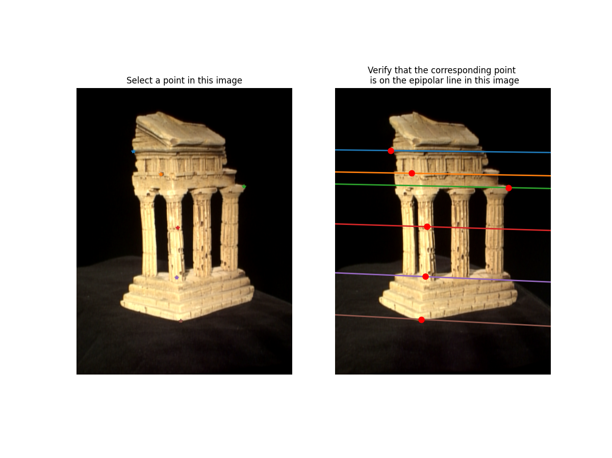We used the supplied to plot the correspondence points in the second image:

1.3 Essential matrix

The Essential matrix relation to F:

So given we can calculate to essential matrix:

1.4 Triangulation

We used supplied points and and their respective matrix cameras and to construct matrix A to solve the following problem:

Where are 3d coordinates.

To do so, we need to first of all, find (assuming that is unit). Given E (and the supplied function) we can get 4 possible candidates for .

We can choose the right matrix by performing the following steps:

* Preform triangulation using supplied points and , matrix and the candidate matrix
* Project the 3D points back to each camera and find the point distance from the camera plane.
* We can assume that the point should have positive Z coordinate (distance of point P from the camera plane)
* Using the above assumption, we can narrow down to one matrix.

So, we can conclude our algorithm as follow:

* Get candidates from matrix
* Find the best match using the method mentioned above
* Preform final triangulation using the chosen matrix

1.5 Putting it all together

We used all the steps above to find 3D points from 2 images and some points correspondence:

* Load the images the points
* Find F
* Use F to find epipolar correspondence points
* Load K matrices
* Find essential matrix E
* Get candidates from matrix
* Find the best match using the method mentioned above
* Preform final triangulation using the chosen matrix

The final 3D model:

